**MMM Database Part**

**Tables used from ENABLE:**

1. DimCorporation
2. DimGeoPanel
3. DimMarketSegmentBrand
4. DimNvsBusinessFranchise
5. DimNvsChannel
6. DimNvsMarket
7. DimTime
8. FactImsSalesMonthly
9. FactImsSalesQuarterly
10. saExchangeRage

**Tables created for MMM:**

1. ABrand
2. DataLiveStatus
3. DIM_PERIOD
4. IMS_PERIOD_LIST
5. TallyTable

Following views are created to build the cube structure.

1. ***FactIMSSalesView***

Table Used: FactImsSalesMonthly, FactImsSalesQuarterly, saExchangeRate

Rules used: we are maintaining a ‘DataSource’ column with two values (‘MTH’ / ‘QTR’) in this view to mark appropriate data source. From saExchangeRate table we are using the latest value of ExchangeRate column for ‘Germany’ with the following query,

select top 1 ExchangeRate from dbo.saExchangeRate where country = 'Germany' order by reportingPeriod desc

Columns used from these tables:

[BrandID]

[PanelID]

[SalesLcUsd] as [LCUSD]

[SalesLcUsd] / (select top 1 ExchangeRate from dbo.saExchangeRate where

country = 'Germany' order by reportingPeriod desc) as [LCEUR]

StandardUnits as Units

[MonthID]

[NvsBusinessFranchiseID]

NvsChannelID

CorporationID

DataSource

1. ***DimFranchiseBrandView***

Table Used: DimNvsMarket, DimMarketSegmentBrand, DimNvsBusinessFranchise, ABrand

Rules in where clause:

TherapeuticAreaDesc in ('General Medicine','Oncology')

and BrandCode is not null

and BrandDesc not like 'UNKNOWN'

and MarketSegmentPriority = 1

Columns used from these tables:

[BrandID]

[BrandCode]

[BrandDesc]

[BrandGroupCode]

[BrandGroupDesc]

[FrsBrandGroupCode]

[MainCorporationDesc]

[MarketSegmentCode as [NvsAtcCode]

[MarketSegmentName as [NvsAtcDesc]

[MarketSegmentShortName as [NvsAtcShort]

[IndicationAreaCode]

[IndicationAreaDesc]

[IndicationAreaShort]

[TherapeuticAreaCode]

[TherapeuticAreaDesc]

[TherapeuticAreaShort]

[IndicationAreaGrpCode]

[IndicationAreaGrpDesc]

[IndicationAreaGrpShort]

[TypeOfBrand]

We are using DimNvsBusinessFranchise table to find the Novartis / Competitor brands. 75% rule is also there to generate one view.

1. ***DimBusinessFranchiseView***

Tables used: FactImsSalesMonthly, DimNvsBusinessFranchise, DimNvsMarket

Rules in where clause:

TherapeuticAreaDesc in ('General Medicine','Oncology')

Columns used from these tables:

NvsBusinessFranchiseID,

IndicationAreaGrpCode

IndicationAreaGrpDesc

IndicationAreaCode

IndicationAreaDesc

NvsBusinessUnitCode

NvsBusinessUnitDesc

NvsBusinessFranchGroupCode

NvsBusinessFranchGroupDesc

NvsBusinessFranchiseCode

NvsBusinessFranchiseDesc

1. ***DimChannelView***

Table Used: DimNvsChannel

Rules in where clause:

Columns from these tables:

[NvsChannelID]

[NvsChannelCode]

[NvsChannelDesc]

[NvsChannelGroupCode]

[NvsChannelGroupName]

[ParallelImportId]

[ParallelImportCode]

[ParallelImportDesc]

[CoMarketingId]

[CoMarketingCode]

[CoMarketingDesc]

[CreateTS]

[UpdateTS]

NvsChannelCode in ('NP','PI','COMA') then 'Novartis'

Or NvsChannelCode in ('NO','COMP') then 'Competitor' as TypeOfBrands

1. ***DimCorporationView:***

Tables used: DimCorporation

Rules in where clause:

Columns from these tables:

[CorporationID]

[CorporationDesc]

[CorporationMncFlag]

[CorporationCode]

[CreateTS]

[UpdateTS]

1. ***DimGeoView***

Tables used: DimGeoPanel

Rules in where clause:

a) [CodeMidasMon] is not null  
 b) [CodeMidasQtr] is not null

Columns from these tables:

[PanelId] + '_QTR' / ‘_MTH’ [PanelId]

[CountryId]

[CountryDesc]

[SubSubRegionDesc]

[SubSubRegionCode]

[SubRegionDesc]

[SubRegionCode]

[RegionCode]

[RegionDesc]

'QTR'/’MTH’ DataType

1. ***DimPeriodView***

Tables used: DIM_PERIOD, FactImsSalesMonthly, FactImsSalesQuarterly

Rules in where clause: Find the latest monthID and mark (true/false) in columns IsMonthly, IsQuarterly

Columns from these tables:

**MMM CUBE Part**

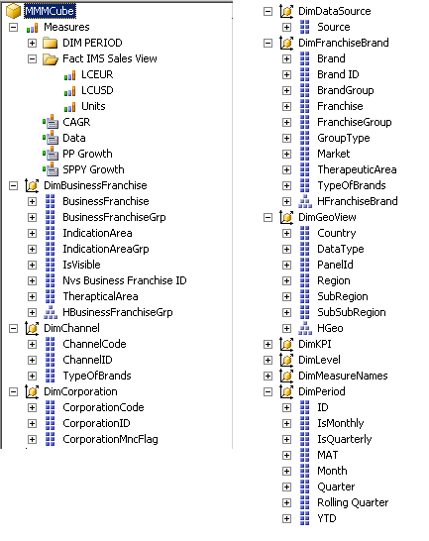

**Basic CUBE diagram:**

